**Quantum Computing: A new revolutionary technology**

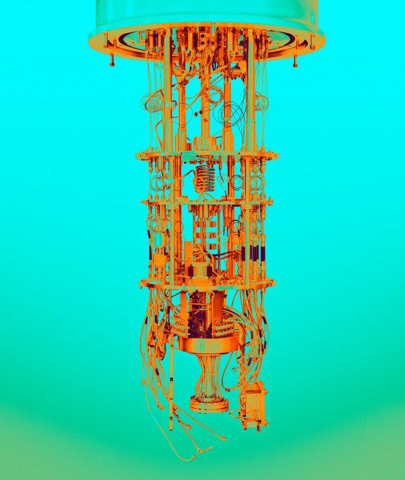

First of all before we dig in about “Quantum Computing” , let us know first what is meant by quantum and computing . In physics, a **quantum** (plural: **quanta**) is the minimum amount of any physical entity (physical property) involved in an interaction. The word *quantum* comes from the Latin *quantus*, meaning "how great". "Quanta", short for "quanta of electricity" (electrons), was used in a 1902 article on the photoelectric effect by Philipp Lenard, who credited Hermann von Helmholtz for using the word in the area of electricity. **Computing** is any activity that uses computers to manage, process, and communicate information for various purposes. It includes development of both hardware and software.

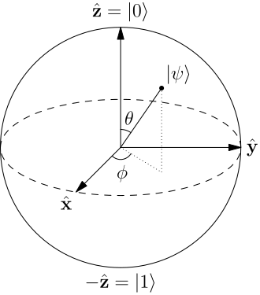 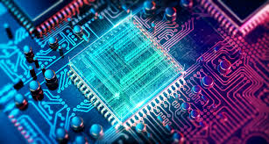

When we combine both , it refers as follows “**Quantum computing** is the use of quantum-mechanical phenomena such as superposition and entanglement to perform computation. A **quantum computer** is used to perform such computation, which can be implemented theoretically or physically.”

Today's computers use bits—a stream of electrical or optical pulses representing 1s or 0s. Everything from your tweets and e-mails to your iTunes songs and YouTube videos are essentially long strings of these binary digits.

Quantum computers, on the other hand, use qubits, which are typically subatomic particles such as electrons or photons. Generating and managing qubits is a scientific and engineering challenge. Some companies, such as IBM, Google, and Rigetti Computing, use superconducting circuits cooled to temperatures colder than deep space. Others, like IonQ, trap individual atoms in electromagnetic fields on a silicon chip in ultra-high-vacuum chambers. In both cases, the goal is to isolate the qubits in a controlled quantum state.

Qubits have some quirky quantum properties that mean a connected group of them can provide way more processing power than the same number of binary bits. One of those properties is known as superposition and another is called entanglement.

**What is a qubit?**



Today's computers use bits—a stream of electrical or optical pulses representing 1s or 0s. Everything from your tweets and e-mails to your iTunes songs and YouTube videos are essentially long strings of these binary digits. Quantum computers, on the other hand, use qubits, which are typically subatomic particles such as electrons or photons. Generating and managing qubits is a scientific and engineering challenge. Some companies, such as IBM, Google, and Rigetti Computing, use superconducting circuits cooled to temperatures colder than deep space. Others, like IonQ, trap individual atoms in electromagnetic fields on a silicon chip in ultra-high-vacuum chambers. In both cases, the goal is to isolate the qubits in a controlled quantum state. Qubits have some quirky quantum properties that mean a connected group of them can provide way more processing power than the same number of binary bits. One of those properties is known as superposition and another is called entanglement.

**What is superposition?**



Qubits can represent numerous possible combinations of *1*and *0* at the same time. This ability to simultaneously be in multiple states is called superposition. To put qubits into superposition, researchers manipulate them using precision lasers or microwave beams.

Thanks to this counterintuitive phenomenon, a quantum computer with several qubits in superposition can crunch through a vast number of potential outcomes simultaneously. The final result of a calculation emerges only once the qubits are measured, which immediately causes their quantum state to “collapse” to either *1*or *0*.

**What is entanglement?**



Researchers can generate pairs of qubits that are “entangled,” which means the two members of a pair exist in a single quantum state. Changing the state of one of the qubits will instantaneously change the state of the other one in a predictable way. This happens even if they are separated by very long distances. Quantum computers harness entangled qubits in a kind of quantum daisy chain to work their magic. The machines’ ability to speed up calculations using specially designed quantum algorithms is why there’s so much buzz about their potential.

That’s the good news. The bad news is that quantum machines are way more error-prone than classical computers because of decoherence.

**What is decoherence?**



The interaction of qubits with their environment in ways that cause their quantum behavior to decay and ultimately disappear is called decoherence. Their quantum state is extremely fragile. The slightest vibration or change in temperature—disturbances known as “noise” in quantum-speak—can cause them to tumble out of superposition before their job has been properly done. That’s why researchers do their best to protect qubits from the outside world in those supercooled fridges and vacuum chambers.

**What is quantum supremacy?**



It’s the point at which a quantum computer can complete a mathematical calculation that is demonstrably beyond the reach of even the most powerful supercomputer.

**Where is a quantum computer likely to be most useful first?**



One of the most promising applications of quantum computers is for simulating the behavior of matter down to the molecular level. Auto manufacturers like Volkswagen and Daimler are using quantum computers to simulate the chemical composition of electrical-vehicle batteries to help find new ways to improve their performance. And pharmaceutical companies are leveraging them to analyze and compare compounds that could lead to the creation of new drugs.

The machines are also great for optimization problems because they can crunch through vast numbers of potential solutions extremely fast. Airbus, for instance, is using them to help calculate the most fuel-efficient ascent and descent paths for aircraft. And Volkswagen has unveiled a service that calculates the optimal routes for buses and taxis in cities in order to minimize congestion. Some researchers also think the machines could be used to accelerate artificial intelligence.

It could take quite a few years for quantum computers to achieve their full potential. Universities and businesses working on them are facing [a shortage of skilled researchers](https://www.technologyreview.com/s/612071/us-takes-first-step-towards-creating-a-quantum-computing-workforce/) in the field—and [a lack of suppliers](https://www.technologyreview.com/s/612760/quantum-computers-component-shortage/) of some key components. But if these exotic new computing machines live up to their promise, they could transform entire industries and turbocharge global innovation.

References:

<https://www.technologyreview.com/s/612844/what-is-quantum-computing/>

<https://www.sciencedaily.com/terms/quantum_computer.htm>

<https://en.wikipedia.org/wiki/Quantum_computing>